

March 2022

**CONTENTS**

1. The Project
2. Dates - Milestones
3. Shareholders - Stakeholders
4. Project financing and cost
5. Construction & Technical features of Patras-Pyrgos Section
6. Operation & Maintenance Services
7. Road Safety
8. Project benefits
9. **The Project**

**One Project, many heroes**

Olympia Odos is one of the most important national strategic projects for the development of the Peloponnese, Western Greece, and Epirus.

It connects these three Regions of Attica, Peloponnese and Western Greece and the Greek capital with the most important gate of Greece to Europe, i.e. the port of Patras.

The new, modern and comfortable motorway offers an enhanced and safe connection to the southwestern part of Greece, and in particular to and from the port of Patras, archaeological sites and tourist areas, while it also strengthens export and agricultural production.

**75 kilometers to the future**

Patras-Pyrgos Motorway is a project of particular importance since it reinstates, after many decades, the connection of the capital with Ancient Olympia. Its completion will trigger a series of beneficial effects on the economic, social and cultural development of the entire region of Western Peloponnese.

The modern Motorway will offer easy access to the area, while it will allow the whole Region to rearrange its tourist and development environment in general, thanks to sustainable economic, environmental and social activities.

**Thanks to the integration of Patras-Pyrgos Motorway in the Concession Project, Olympia Odos becomes the third longer motorway in Greece, with a total length of 277 km. The new 75km of the modern motorway will link Patras Bypass with the northern entrance of Pyrgos.**

|  |  |  |
| --- | --- | --- |
| **Section** | **Length** | **Remarks** |
| From Elesfina-Thiva I/C to Ancient Korinthos I/C | 64 km. | Existing motorway - refurbishment works |
| From Ancient Korinthos I/C to the First Patras Bypass I/C (Κ1) | 120 km. | Construction of new motorway which in general follows the alignment of the existing NNR. |
| Patras Bypass: From the First I/C (K1) to the last I/C (Κ7, Midilogli) | 18 km. | Existing motorway - refurbishment works |
| From Midilogli I/C to Pyrgos I/C | 75 km. | Reconstruction of 13 km and construction of 62km of new motorway |
| **Total** | **277 km.** |  |
| **\* I/C:** Interchange | | |

1. **Dates - Milestones**

* In 2001, the Greek State conducted international restricted tender procedures for the implementation of the Olympia Odos Project under concession agreement and co-financing.
* In 2007, the consortium named APION KLEOS MOTORWAY SA, in which participate large European and Greek construction companies, was appointed Contractor of the Project “Elefsina-Korinthos-Patras-Pyrgos-Tsakona Motorway”.
* On July 24, 2007 the Greek State and APION KLEOS MOTORWAY SA entered into the Concession Agreement for the Design, Financing, Construction, Operation, Maintenance and Exploitation of the project, which then, on November 29, 2007 was ratified by the Greek Parliament by a large majority.
* On August 4, 2008, the concession commencement has been entered into.
* In late November 2010, the lenders suspended the financing. For a period longer than six months, the construction continued thanks to the financial resources of the construction companies.
* In the middle of 2011, the construction activity was suspended due to the lack of resources and unpaid works. The securing works continued on the project, as well as the daily operation and maintenance, services that are necessary to ensure road safety.
* On December 17, 2013, the reset of the Project has been entered into.
* The “Agreement on the timely completion of the Project” has been entered into on July 25, 2016.
* The construction of the Motorway was completed on August 31, 2017.

**Patras-Pyrgos Milestones**

* **April 4, 2014:** The section of Patras-Pyrgos-Tsakona is excluded from the Project, pursuant to a Ministerial Decision.
* **September 2014** The Concession Company and APION KLEOS Construction Company elaborated the designs of Patra-Pyrgos section and delivered them to the State.
* **2015**: The State segregated Patras-Pyrgos section into 8 separate contracts and proceeded with a public procurement.
* **2018**: The State entered into 3 (out of the 8) contracts. Since then, the progress of works was particularly slow (less than 1%, 3 million euros in one year).
* **2nd semester 2019:** The re-integration of Patras- Pyrgos Section in Olympia Odos Concession Project is being reconsidered.
* **January 2020:** A Memorandum of Understanding has been entered into between the State and Olympia Odos.
* **October 2020:** Approval by the DG Grow and ratification of the amendment regarding the reintegration of Patras-Pyrgos Section in the Concession Project.
* **December 2021:** Approval by the DG Comp, ratification of the agreement by the Greek Parliament and financial closing regarding the re-integration of Patras- Pyrgos section in Olympia Odos.

1. **Shareholders - Stakeholders**

Olympia Odos is the Concession Company for the Project, which undertook, by an agreement entered into with the Greek State in 2008, to design, construct, finance, operate and maintain the Motorway over a period of thirty (30) years. The companies participating in the société anonyme are extremely experienced in designing and implementing similar large scale projects in Greece and around the world.

**Concession Company** OLYMPIA ODOS S.A.

**Shareholders** VINCI CONCESSIONS S.A.S. 29.9%

AVAX SA 19.1%

HOCHTIEF PPP SOLUTIONS GmbH 17%

AKTOR CONCESSIONS 17%

GEK TERNA SA 17%

The same companies participate also in the construction of the new Patras-Pyrgos Section, except HOCHTIEF SOLUTIONS AG.

**Shareholders**

AVAX SA 35,695%

AKTOR SA 35,695%

TERNA S.A. 28,600%

VINCI CONSTRUCTION GRANDS PROJETS 0,010%

100%

**Implementation bodies**

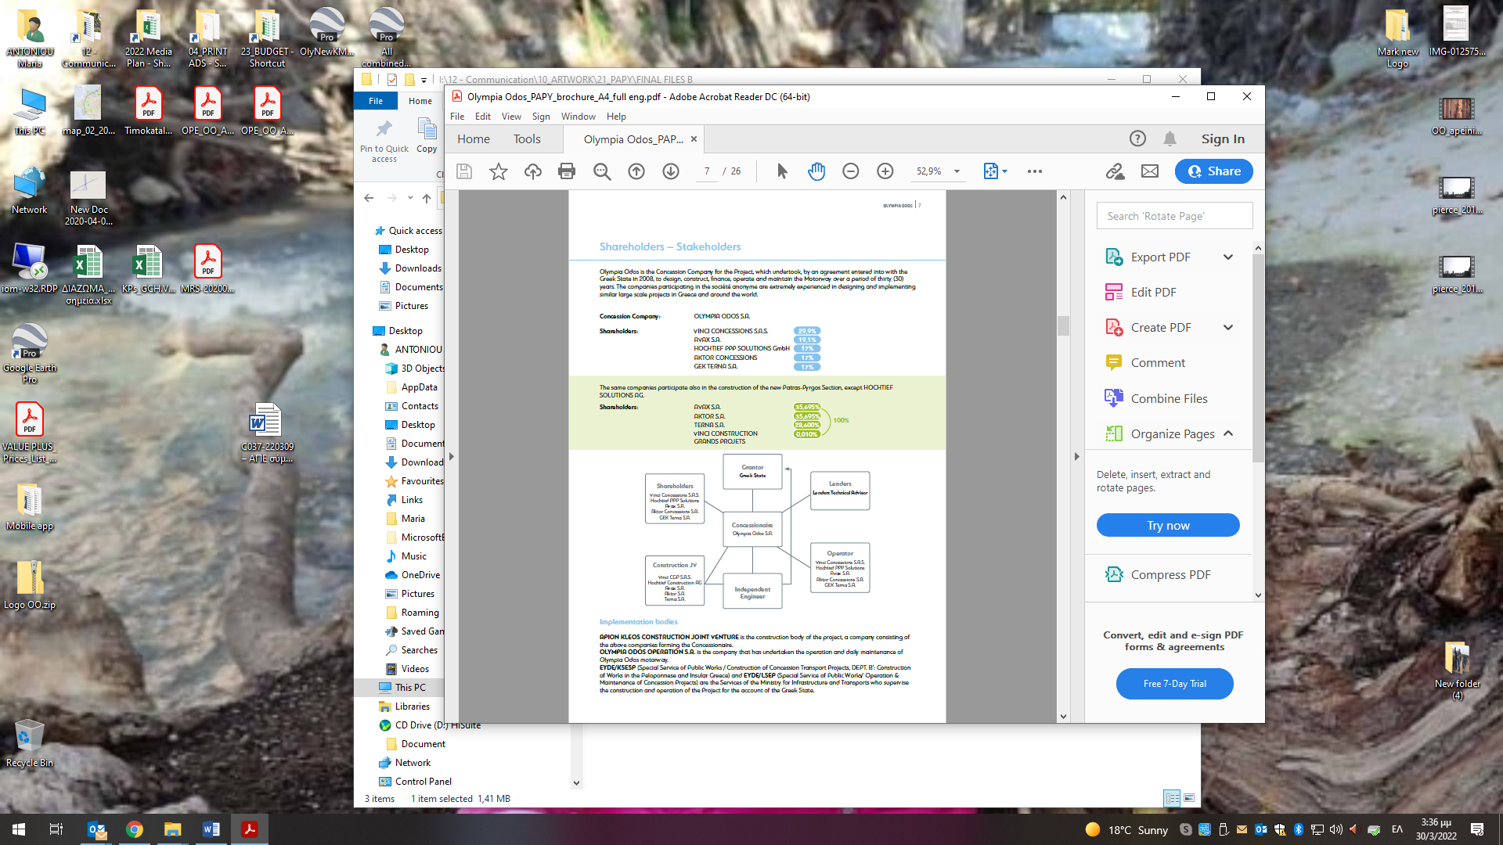

**APION KLEOS CONSTRUCTION JOINT VENTURE** is the construction body of the project, a company consisting of the above companies forming the Concessionaire.

**OLYMPIA ODOS OPERATION S.A.** is the company that has undertaken the operation and daily maintenance of Olympia Odos motorway.

**EYDE/KSESP** (Special Service of Public Works / Construction of Concession Transport Projects, DEPT. B’: Construction of Works in the Peloponnese and Insular Greece) and **EYDE/LSEP** (Special Service of Public Works/ Operation & Maintenance of Concession Projects) are the Services of the Ministry for Infrastructure and Transports who supervise the construction and operation of the Project for the account of the Greek State.

1. **Financing and cost**

The total construction cost of Korinthos-Patras section amounted to € 1.487 million euros and was financed by a combination of private equity (bank loans and equity), EU funds, the contribution of the users and the Greek State.

**Financing sources of Patras-Pyrgos section - Resource allocation over the construction period**

The **total construction cost** of Patras-Pyrgos Section will amount to EUR 331 million and is financed by a combination of shareholders’ private equity, bank loans, EU funds, and the contribution of the Greek State.

In particular, during the construction period, the Project is financed as follows:

* 35% with Concessionaire funds (bank loans & equity);
* 65% from the European Union and the Greek State.

\**Note that the above data are based on the financial model of the Project, which is dynamic, in the sense that it is updated with the actual project data, on a semi-annual basis. Therefore, minor variations may arise between semesters.*

1. **Construction & Technical features of Patras-Pyrgos Section**

More than 800 people will be employed in the worksites which will be developed for the construction of Patras-Pyrgos section motorway.

The first section of 13km from Midilogli to Kato Achaia will be refurbished by widening the existing Patras-Pyrgos national road. The remaining section is a greenfield construction (new alignment in Ilida Valley).

* The new motorway will have **2 traffic lanes and an Emergency Lane per direction**, with a median in between the two directions.

|  |  |  |
| --- | --- | --- |
| **Interchange** | **K.P.** | **Population** |
| Midilogli Semi-I/C | 0+000 | 12,986 |
| VIPE | 6+950 | 16,265 |
| Kato Achaia | 17+760 | 17,888 |
| Varda | 33+040 | 10,046 |
| Kylini | 46+020 | 19,134 |
| Gastouni | 53+675 | 24,039 |
| Amaliada | 62+680 | 24,235 |
| Pyrgos | 73+840 | 73,925 |
| **TOTAL** |  | **198. 518** |

* **8 interchanges** will connect the motorway with many villages and cities, as well as the industrial zone of Patras, with almost 200,000 beneficiaries:
* **2 Frontal Toll Stations:**
  + **Kato Achaia** (tolling zone: Midilogli - Kylini);
  + **Chanakia** (tolling zone: Kylini - Pyrgos).
* **2 ramp toll stations** at Kato Achaia and Amaliada.
* **15 bridges**
* **27 overpasses & 37 underpasses**
* **150 culverts**
* **7,250m of retaining walls**
* **2 Motorists Service Stations** (**Kareika** and **Pyrgos**, on both traffic directions)
* **1 backup Traffic Management Center** (which comprises Traffic Police facilities) in Pyrgos
* **2 Customer Service Centers**

**Construction milestones**

* The construction works will start in **March 2022.**
* Operation commencement (ready to be safely opened to the users) of the reconstructed section of **Midilogli-Kato Achaia by the end of July 2025**, while the full completion of the segment will be effected at a subsequent stage.
* Operation commencement of the **Kato Achaia - Pyrgos section within the first quarter of 2025.**

**Technical challenges of the Project**

In construction terms, note the following points of interest:

* Extensive earthworks, with a total deficit of material for filling of about ≈3.5 million m3;
* Widening of the first 13km section, with simultaneous traffic arrangements during the construction phase;
* The fifteen (15) bridges of the new motorway, the larger of which being the 240m long Pinios River Bridge, which is the longest bridge of the entire Olympia Odos Motorway.

**Technical features**

|  |  |  |  |  |  |
| --- | --- | --- | --- | --- | --- |
| **Section** | **Elefsina - Korinthos** | **Korinthos - Patras** | **Patras Bypass** | **Patras-Pyrgos** | **TOTAL** |
| Interchanges | 11 | 13 | 5 | 8 | 37 |
| Overpasses | 13 | 22 | 3 | 27 | 65 |
| Underpasses | 37 | 140 | 27 | 37 | 241 |
| Bridges | 16 | 47 | 17 | 15 | 95 |
| Tunnels | 5 | 12 | 12 | - | 29 |
| Tunnels length (m) | 4,473 | 16,011 | 5,117 | - | 25,601 |
| Culverts | 154 | 165 | 50 | 150 | 519 |
| MSS | 1 | 5 | 0 | 2 | 8 (15)* |
| Technical Bases / TMC | 1/1 | 2 | 1/1 | 1 | 5 |
| Total length (km) | **64** | **120** | **18** | **75** | **277** |

*\* All MSSs are bidirectional (on both directions), except Zevgolatio MSS (only in the direction to Athens).*

1. **Operation & Maintenance Services**

Since August 2008, **OLYMPIA ODOS OPERATION S.A.** manages the network from Elesfina to Patras, a total length of 202km.

Patrols, emergency intervention teams and maintenance personnel, in cooperation with the Traffic Police, the Fire Brigade as well as the private road assistance companies, are in full readiness to provide road assistance to the passing drivers in case of an incident, 24 hours a day and 365 days a year, as well as to ensure a high level preventive and corrective maintenance of the network. The average response time to incidents is approximately **14 minutes**.

Upon completion of the construction of Korinthos - Patras section and the installation of new technology systems on the Motorway, the drivers enjoy high level services such as information about the travel time (actual and predicted traffic for a period of 72 hours), traffic conditions and weather forecasts.

|  |  |
| --- | --- |
| **Current organization of the motorway** | **Organization after the Patras- Pyrgos construction** |
| **2 Operation Sectors** (Sector 1: Elefsina - Xylokastro, Sector 2: Xylokastro- Midilogli); | **2 Operation Sectors** (with redistribution of their respective jurisdiction boundaries) |
| **2 Traffic Management Centers**  (TMC1 at Nea Peramos, TMC2 at Rion) | **2 permanently manned TMCs** (TMC1 at Nea Peramos, TMC2 at Rion and a backup, non-manned at Pyrgos) |
| **4 Operation & Maintenance Technical Bases** (N. Peramos, Kiato, Akrata, Rion) | **5 Technical Bases**  (N. Peramos, Kiato, Akrata, Rion, Pyrgos) |
| **43 Patrol and Intervention vehicles,**  **and 16 Project Machinery** | **58 Patrol & Intervention vehicles,**  **and 24 Project Machinery** |
| **5 Frontal Toll Stations** (Elefsina, Isthmos, Kiato, Eleonas, Rion) | **7 frontal Toll Stations** (Elefsina, Isthmos, Kiato, Eleonas, Rion, Kato Achaia and Chanakia) |
| **470 employees** for the Operator and  **30 employees** for the Concession Company | **550 employees for the Operation and**  **30 employees for the Concession of the Motorway** |
| **150 persons of Subcontractors’ additional personnel** (Road Assistance, Cleaning, Green areas, Safety Barriers repair, E/M Maintenance, etc.). | **180 persons of Subcontractors’ additional personnel** |

**Innovations and Services**

All innovations developed by Olympia Odos will be immediately available on Patras-Pyrgos section. By way of example, from the very first day of operation of the new motorway, the following will be available to the users:

* The **HYBRID** tolling system to be used with the OLYMPIA PASS transponder;
* The possibility to make fully contactless transactions using **credit/debit cards at all POSs of the Automatic Payment Machines (APM) lanes**;
* Persons with Disabilities will be exempted from the obligation to pay tolls, simply by presenting their Parking Card for Persons with Disabilities or the special identity card for war disabled persons.

1. **Road Safety**

Patras-Pyrgos section is an old road axis presenting particularly bad statistics regarding road safety. More than 66 fellow citizens lost their life while tens of others were injured, many of whom very seriously, in just the last six (6) years.

The main reasons are the lack of central median, the poor pavement (lack of maintenance), the level crossings, the illegal and unsecured entrances and exits from the road, the obsolete design of the project dated 1980 and the lack of operation and maintenance services.

Along the new Patras-Pyrgos Motorway, millions of vehicle kilometers will be traveled in safe, comfortable and time saving conditions.

**Motorway equals safety**

The importance of the construction of roads with specific features, and the existence of a comprehensive mechanism for the provision of road safety services is typically proven by the case of Patras-Pyrgos section.

The decrease of the fatal accidents from the commencement of the Concession Project to date amounts to **93%**, while the few accidents that still occur are all due to human factors.

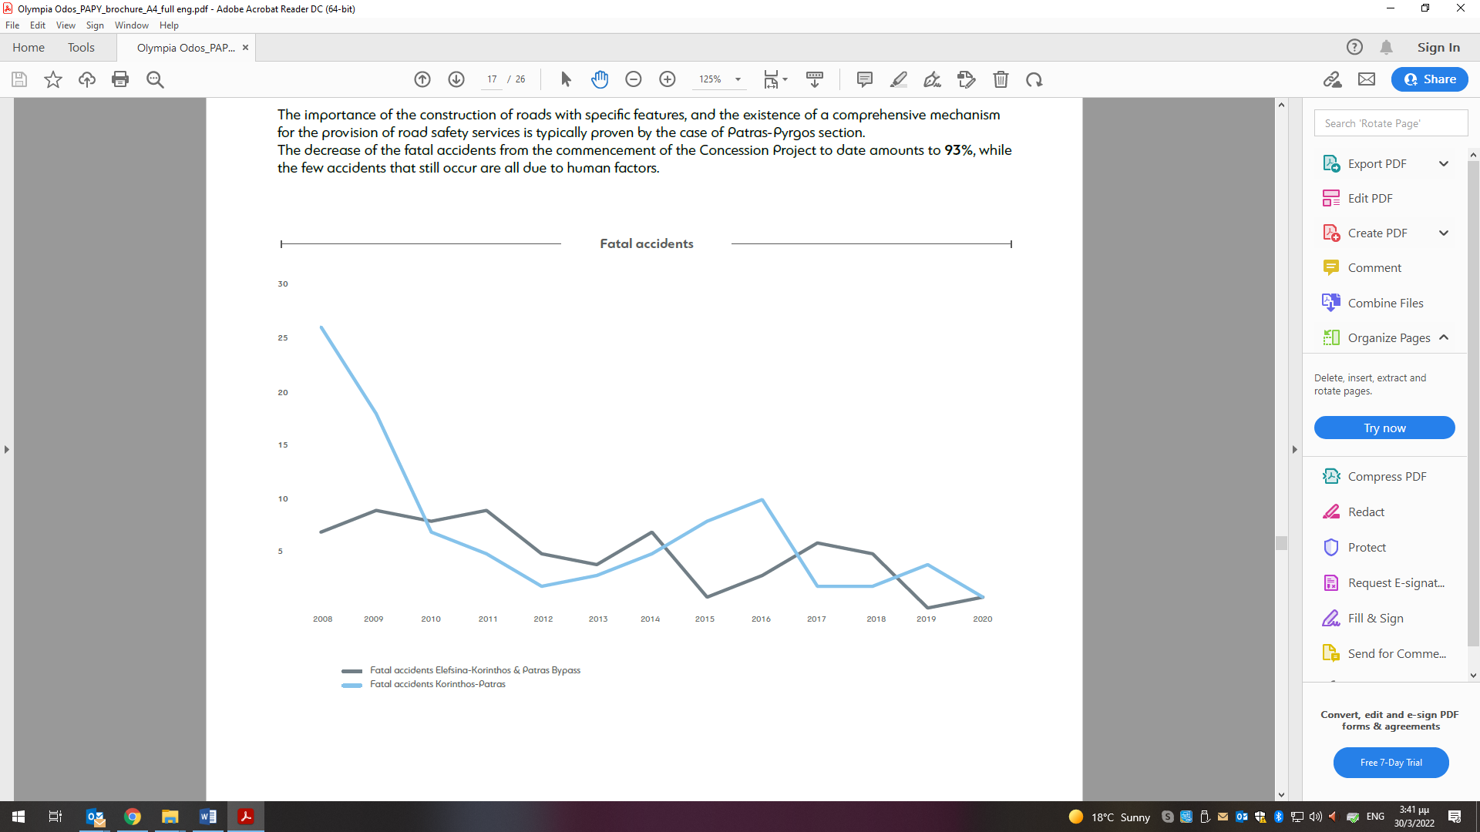 **8. Project’s Benefits**

**Project’s direct benefits**

* **Improvement of Road Safety level**
* Separation of the two traffic directions with a central median.
* Interchanges connecting the motorway to the other road network
* Larger number of traffic lanes ensures safe overtakings;
* Drivers enjoy an environment presenting uniform features
* 24 hours monitoring of the motorway by the Operation personnel and timely intervention in case of emergencies.
* **Decreased travel time between Athens and Patras** (by 15-20 minutes)
* **High level of Road Services and increased traffic capacity;**
* **Reduced emissions of pollutants;**
* **Travel cost/vehicle operation cost savings**
* Reduced vehicle operating costs (fuels, maintenance, tires, etc.);
* Passengers/goods traveling along the motorway;
* Decongestion of alternative routes because traffic is diverted to the Motorway; improvement of the quality of life in the affected areas.

**Socioeconomic and development benefits**

* **Effects on the Economy and Employment**
* Direct annual jobs during the construction period: 800 persons
* Annual jobs for the maintenance and operation: Currently 500 people, while in the future 580 people
* Indirect annual jobs in the field of materials supply, construction/operation support.
* **Growth aspects of the Project**
* Increase of industrial production (connectivity improvement);
* Increase the attractiveness of the region (new investments);
* Increase domestic and international tourism (thanks to easy access from Patras port).
* **Indirect social impact**
* Easy access to urban centers (e.g. Athens, Patras, Pyrgos);
* Improved citizens’ mobility and lifting of social exclusion and poverty

**Patras–Pyrgos specific benefits**

Reduced travel time along Patras-Pyrgos, by ~ 40 minutes. Consequently, the whole trip from **Athens to Pyrgos, using the new Motorway, will just take 2 hours and 45 minutes.**

**In particular, to serve Patras Industrial Zone (VIPE), a** 25km regional freeway**,** starting from the area of Rion (18th km of Patras Bypass) and ending at Patras VIPE Interchange (the first 7 kilometers of the new motorway) will be completed.

**Boosting the local economy and in particular the agricultural production of Ilia Prefecture.**

Tens of thousands of agricultural and processed products (fruit & vegetables, canned products, etc.) are traveling every year from Ilia Prefecture to the large cities, mainly Athens, and other international destinations. For Ilia Prefecture, the agricultural production is the major field of its overall economic activity.

**Connection with the Ionian Islands**

Given that the starting point of the sea links between the mainland and the Ionian Islands (Zante, Ithaca, Kefalonia, Cythera) is Ilia Prefecture, the construction of Patras-Pyrgos section will help eliminate the difficulties of such connection between the islands and the other areas of Greece and will further boost tourism development in these areas.

**Tourism development in Western Peloponnese**

Western Peloponnese, from Patras to its southernmost point, the Messinian Mani, offers amazing sandy beaches of great beauty, among the most beautiful beaches of Greece.

However, the lack of transport infrastructure prevented the tourism development of this region up to satisfactory levels. The construction of Patras-Pyrgos in combination with the current sea links and the host ports (Patras, Kylini, Katakolo, etc.) as well as the International Airport of Araxos will certainly contribute in creating a second wave of development of tourist facilities in the entire region. The Motorway will significantly contribute to, indirectly, facilitate tourists arriving by cruise ships to Katakolo Port having as final destination Ancient Olympia.

**Ancient Olympia and cultural heritage monuments**

In Ilia Prefecture one comes across some of the most important cultural monuments as well as areas of particular environmental importance, such as the extensive archaeological Site of **Ancient Ilida**, the Ancient Theater of **Platania**, the **Forest of Foloi** in Ancient Olympia, the **Kotichi Lagoon, the Temple of Apollo Epicurius**. Moreover, important Byzantine and MetaByzantine monuments can be found in the area, such as the very **important port during the Rule of Francs**, the **Glarentza Castle**, the impressive **Chlemoutsi Castle**, the **Monastery of Fragavilla**, the **Church of Panagia Katholiki at Gastouni**.

The jewel of Ilia and the most famous sanctuary of Ancient Greece, is of course **Ancient Olympia.** The place where the Olympic Games were born, an institution with great radiance and shine from the ancient time to date.

It is typical that despite its isolated location close to the western coast of the Peloponnese, in the ancient times Olympia became the most important religious and sport center all over Greece.